Project Design Phase
Solution Architecture

Date | 06 July 2026
Team ID
Project Name | Online Complaint Registration System
Maximum Marks | 4 Marks

Solution Architecture:
Solution architecture describes the overall structure of the Online Complaint Registration System and explains how different components interact with each other to solve the complaint management process.
The main goals of the solution architecture are to:
- Provide a digital platform for users to register and track complaints online.
- Establish smooth communication between users, agents, and administrators.
- Create a secure and scalable system using MERN stack technologies.
- Manage complaint records, user details, and status updates efficiently through a centralized database.
- Provide role-based access control for User, Agent, and Admin modules.

Example - Solution Architecture Diagram:
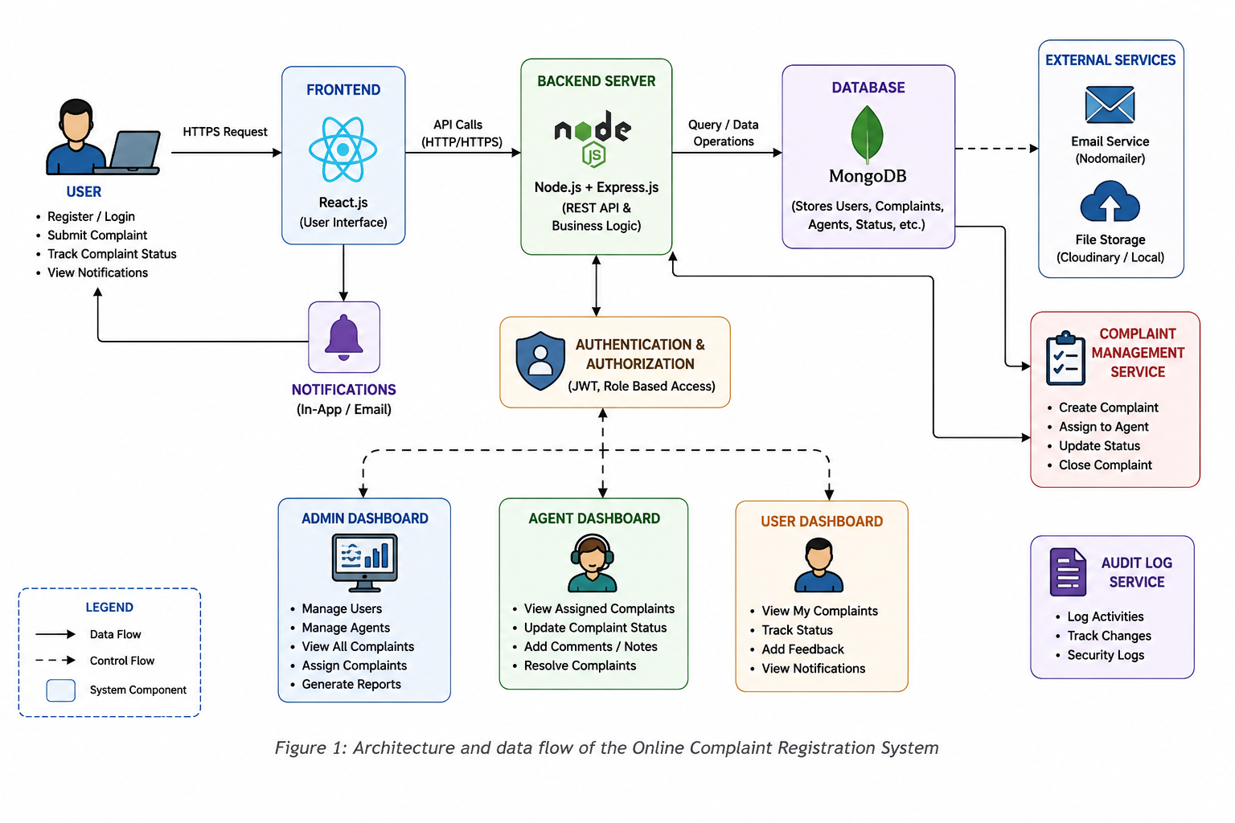

Reference:
https://react.dev/
https://nodejs.org/
https://expressjs.com/
https://www.mongodb.com/mern-stack
https://vercel.com/docs

